From Commodities to Capabilities:
Strategic Export Diversification for Indonesia’s Industrial Policy

Author names:
- Nadira Firinda (Bank Indonesia) nadira_firinda@bi.go.id
- Ginanjar Utama (Bank Indonesia) ginanjar_utama@bi.go.id

Postal address:
Bank Indonesia, Jl MH Thamrin no 2 10350 Jakarta, Indonesia

Corresponding Author:
Nadira Firinda, nadira_firinda@bi.go.id

The views expressed in this publication are those of the authors and do not reflect the official stance of Bank Indonesia
Contents
Abstract 3
1 Introduction 3
2 Literature Review 6
2.1 Economic Complexity Theory 6
2.1.1 Theoretical Foundations 6
2.1.2 Critiques and Methodological Extensions 7
2.1.3 The Optimization Turn in Economic Complexity 8
2.1.4 The 4W Policy Framework 8
2.2 Industrial Policy in Developing Economies 10
2.2.1 Theoretical Perspectives on Industrial Policy 10
2.2.2 Proximity-Driven Industrial Policy 11
3 Data and Methodology 12
3.1 Data Sources 12
3.2 Economic Complexity Metrics 12
3.2.1 Revealed Comparative Advantage (RCA) 12
3.2.2 Product Complexity Index (PCI) 13
3.2.3 Product Space and Proximity 13
3.2.4 Density and Distance 14
3.2.5 Complexity Outlook Gain (COG) 14
3.3 Strategic Opportunity Scoring 14
3.4 Analytical Workflow 15
3.5 Caveat 15
4 Results 16
4.1 Current Export Structure 16
4.2 Complex Products in Current Exports 17
4.3 Strategic Diversification Opportunities 18
4.4 Product Space Positioning 21
4.5 Robustness Check: Temporal Stability Analysis 23
4.6 Sensitivity Analysis: Scoring Weight Variation 25
5 Discussion 28
5.1 The Complexity Gap and Its Implications 28
5.2 Operationalizing the 4W Framework 28
5.2.1 What: Sectoral Priorities 28
5.2.2 When: Phased Implementation 30
5.2.3 Where: Geographic Specialization 30
5.2.4 Who: Institutional Orchestration 31
5.3 Addressing Binding Constraints 32
5.4 Political Economy of Downstreaming and Geopolitical Pressures 33
5.5 Implementation Risks 35
6 Conclusions 36
References 39
Appendices 42

Abstract

Indonesia’s nickel downstreaming policy has delivered impressive export growth, yet the economy’s average Product Complexity Index remains −0.523—firmly in the low-complexity periphery of the global product space. Volume-based resource processing has not generated the productive capabilities that underpin sustained high-income growth. This paper applies the economic complexity framework to chart a strategic diversification pathway, constructing a composite scoring function (PCI × Density, restricted to PCI > 0) that balances complexity gains against feasibility constraints, supplemented by a qualitative policy-salience filter that screens for stepping-stone value, technology viability, and strategic relevance. From an initial model-ranked portfolio of ten products, the filter yields eight policy-adjusted targets clustering into three industrial pillars: advanced materials and chemicals, precision machinery and industrial equipment, and microelectronics. Sensitivity analysis across five weighting scenarios confirms that a core subset—photographic laboratory apparatus (semiconductor lithography), chemical elements for electronics, laser working machines, and electronic integrated circuits—is robust to the policymaker’s relative emphasis on ambition versus feasibility. A 4W implementation framework (What, When, Where, Who) translates these targets into phased sectoral priorities, geographically specialised clusters, and coordinated institutional roles, with Danantara positioned as a de-risking catalyst for unrelated-diversification bets that exceed private-sector risk tolerance. However, the strategy is inseparable from Indonesia’s political economy: WTO disciplines, the EU–Indonesia CEPA, and the February 2026 US–Indonesia trade agreement progressively constrain the export-ban instruments that launched downstreaming, requiring a transition toward WTO-compatible industrial policy tools. The paper argues that reaching Golden Indonesia 2045 demands not merely product-space optimisation but the institutional and political capacity to navigate an increasingly contested geopolitical landscape.

JEL classification: O14, O25, F14, L52, L60

Keywords: Economic complexity, industrial policy, export diversification, Indonesia, capabilities, ECI, product space, structural transformation

Introduction

Indonesia's economic development has reached a turning point. As the world's seventh-largest economy by purchasing power parity and the largest economy in Southeast Asia, Indonesia possesses substantial scale advantages including a population of 273 million, abundant natural resources, and a strategic geographic position within the Association of Southeast Asian Nations (ASEAN). The government's ambitious Golden Indonesia 2045 vision targets high-income status, defined as USD 14,000 per capita income, and a position among the world's top five economies. However, achieving these objectives requires fundamental structural transformation that has thus far proven elusive.

Table 1 Economic Complexity Index (ECI) Peer comparison from The Atlas of Economic Complexity
ECI Rank | Year | Country | ECI | Change Over 5 Years | COI | COI Rank
32 | 2024 | Malaysia | 0.82 | -5 | 0.92 | 32
34 | 2024 | Thailand | 0.79 | -2 | 1.54 | 9
43 | 2024 | Philippines | 0.69 | -3 | 0.60 | 44
45 | 2024 | Vietnam | 0.63 | 10 | 0.79 | 38
69 | 2024 | Indonesia | 0.23 | -11 | 1.26 | 17

The Complexity Outlook Index (COI) measures the value of a country’s nearby diversification opportunities in the product space. While ECI captures current productive complexity, COI captures the potential for future complexity upgrading based on products that are close to the country’s existing capabilities.

Despite sustained GDP growth averaging roughly 5% annually, Indonesia's Economic Complexity Index (ECI) has remained stagnant at 0.23 in 2024, ranking 69th globally (Table 1). This complexity stagnation stands in stark contrast to regional peers who have successfully upgraded their productive structures. Vietnam, leveraging strategic foreign direct investment in electronics manufacturing, has achieved an ECI of 0.63 (ranked 45th), with electronics now comprising 38% of total exports. Thailand has established itself as the "Detroit of Asia" through automotive cluster development, achieving an ECI of 0.79 (ranked 34th). Malaysia, through sustained investment in electronics and semiconductor manufacturing, has attained an ECI of 0.82 (ranked 32nd).

The divergence between Indonesia's economic scale and its complexity profile presents what this paper terms the "downstreaming paradox." Current industrial policy, exemplified by the nickel downstreaming initiative, has generated substantial export value growth from USD 1.3 billion (2014) to USD 35 billion (2024). However, this value addition has occurred primarily through intermediate processing stages - ferronickel, nickel pig iron, and basic chemicals - that remain characterized by low Product Complexity Index (PCI) values. The export basket continues to be dominated by commodities such as coal (PCI: -2.19) and palm oil (PCI: -2.92), leaving the economy vulnerable to global price volatility and failing to generate the productive capabilities necessary for sustained high-income growth (Figure 1).

Figure 1 Export basket and export complexity in Indonesia 2024. Source: https://atlas.hks.harvard.edu/countries/360/export-complexity
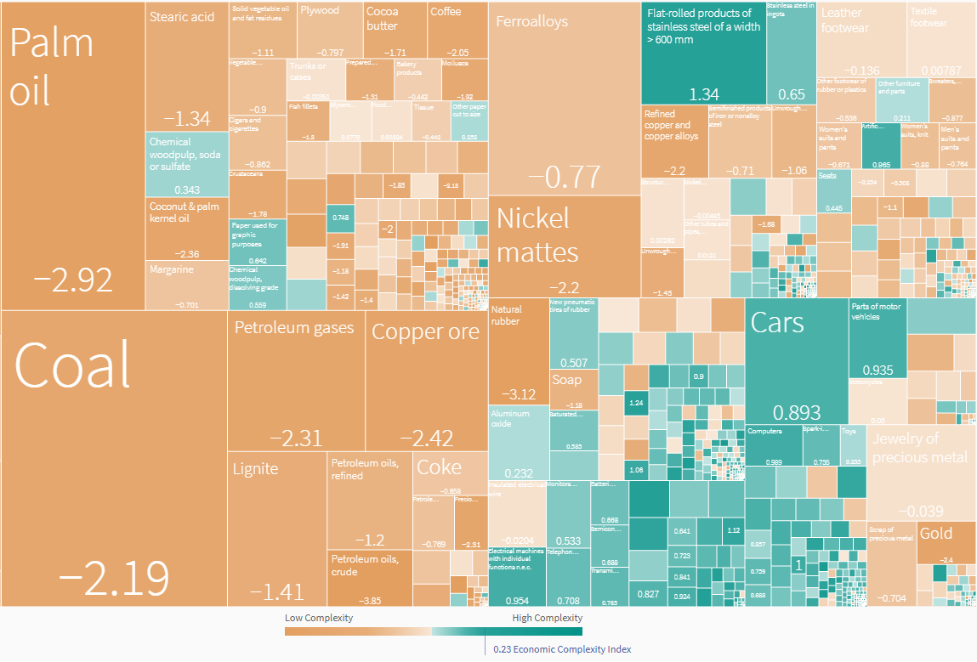

The productivity data reinforces these concerns. Indonesia's labor productivity stood at USD 14 per hour in 2023, significantly below Malaysia's USD 26 per hour and Singapore's USD 74 per hour (Oxford Business Group, 2024). More troubling, productivity growth has decelerated from approximately 3% annually (2002-2016) to approximately 2% annually thereafter (McKinsey & Company, 2025). This slowdown directly undermines Indonesia's ability to achieve the 5.4% annual GDP growth required for the Golden Indonesia 2045 vision, which necessitates productivity growth accelerating to 4.9% annually (McKinsey & Company, 2025). Without structural transformation toward more complex, knowledge-intensive activities, such productivity acceleration appears unattainable.

This paper addresses several interconnected research questions that have significant implications for Indonesia's industrial policy design. (1) How do scoring- and portfolio-based recommendations differ from conventional relatedness–complexity heuristics for Indonesia? (2) Which products form an empirically grounded set of ‘strategic bets’ capable of raising Indonesia’s complexity under capability constraints? and (3) How can these results be operationalized into implementable industrial policy priorities—including for current focus areas such as EVs, batteries, and downstream processing—without overcommitting to technologically distant leaps?

The objective of this paper is to construct an empirically grounded export diversification strategy for Indonesia by scoring products on the trade-off between complexity (desirability) and density (feasibility), assembling the top-ranked targets into a coherent portfolio, and translating that portfolio into a phased policy roadmap using the 4W framework—bridging the gap between economic complexity analytics and implementable industrial policy.

Economic complexity provides a useful lens for diagnosing this challenge and for designing a more disciplined diversification strategy. The Economic Complexity Index (ECI) summarizes the diversity and sophistication of an economy’s export basket, while the Product Complexity Index (PCI) captures the implicit capability requirements of products. The product space framework adds a structural constraint: economies tend to diversify into products that are ‘nearby’ in capability space, making the transition path-dependent.

This paper advances the application of economic complexity to Indonesia’s industrial transformation in three ways. First, it maps Indonesia’s current export strengths and identifies where complexity is (and is not) emerging within the existing basket. Second, it moves beyond static relatedness–complexity rankings by assembling a practical *portfolio* of diversification targets that balances desirability (high PCI and/or high complexity outlook gain) with feasibility (density and distance). Third, it translates the resulting portfolio into actionable policy guidance using a multi-horizon perspective and the 4W framework, linking target selection (What) to sequencing (When), place-based execution (Where), and institutional mobilization (Who).

The remainder of this paper is organized as follows. Section 2 reviews the theoretical foundations of economic complexity theory and industrial policy in developing economies, including recent critiques and methodological extensions. Section 3 details the data sources and analytical methodology employed in this study. Section 4 presents the empirical results, including Indonesia's current export structure, complexity profile, and strategic opportunity identification. Section 5 discusses the policy implications, operationalizing the findings through the 4W framework (What, When, Where, Who) and addressing binding constraints. Section 6 concludes with a synthesis of findings, limitations, and directions for future research.

Literature Review

Indonesia's development trajectory cannot be fully captured by conventional growth models that focus primarily on capital accumulation and diminishing returns (Solow, 1956; Harrod, 1939; Domar, 1946). While these neoclassical frameworks have provided foundational insights into economic growth, they offer limited guidance for understanding the structural transformation required to escape the middle-income trap. The Economic Complexity framework, developed by Hausmann and Hidalgo and their collaborators, offers a more nuanced analytical lens by emphasizing productive capabilities, knowledge accumulation, and strategic product diversification. This chapter reviews the theoretical foundations and empirical evidence underlying both economic complexity theory and industrial policy in developing economies, establishing the conceptual framework for analyzing Indonesia's industrial policy strategy.

Economic Complexity Theory

Theoretical Foundations

The economic complexity framework emerged from pioneering work by Hidalgo, Hausmann, and their collaborators at Harvard's Growth Lab, fundamentally reconceptualizing how productive knowledge is organized and transferred across economies. The seminal contribution by Hidalgo et al. (2007) introduced the concept of the Product Space, a network representation of the relatedness between traded products based on the probability that countries export them simultaneously. This network structure revealed that products are not randomly distributed but cluster according to shared capabilities, with some regions of the product space being densely connected while others remain sparsely linked. Countries positioned in denser regions enjoy greater opportunities for diversification, while those trapped in peripheral areas face significant barriers to structural transformation.

Building on this foundation, Hidalgo and Hausmann (2009) developed the Economic Complexity Index (ECI), a measure that captures the diversity and sophistication of a country's export basket, and its complementary Product Complexity Index (PCI), which ranks products by the capabilities required to produce them. The methodology draws on network science and information theory to infer the breadth and depth of productive knowledge embedded in an economy. Countries with high ECI values tend to export diversified baskets of sophisticated products that few other countries can produce, — a reflection of accumulated tacit knowledge, institutional capabilities, and supply chains that are hard to replicate.

The predictive power of economic complexity has been empirically validated across multiple studies. Hausmann et al. (2014) demonstrated that ECI significantly outperforms GDP per capita in forecasting subsequent economic growth, suggesting that a country's current productive structure contains information about its future trajectory that income levels alone cannot capture. This reframes development strategy: rather than focusing solely on factor accumulation, countries should strategically acquire new capabilities that enable diversification into more complex products.

The proximity principle is the key empirical regularity: which holds that countries are most likely to successfully diversify into products that are closely related to their existing export basket (Hidalgo et al., 2007). This path dependence implies that current capabilities both enable and constrain future opportunities. Countries cannot arbitrarily leap to high-complexity products; instead, they must build stepping stones through related industries that gradually expand their capability base. This insight has important implications for industrial policy design, as it suggests that strategic sector selection should consider not only a product's complexity but also its relatedness to existing strengths.

Critiques and Methodological Extensions

Despite its theoretical elegance and empirical success, the economic complexity framework has faced several important critiques that have spurred methodological extensions. A significant limitation identified by Stojkoski et al. (2023) concerns the unidimensional nature of trade-based complexity measures. Their analysis demonstrates that economic complexity manifests across multiple domains, including technological innovation, scientific research output, digital services, and knowledge-intensive service exports, each capturing distinct dimensions of productive capabilities. Countries may exhibit high complexity in one domain while lagging in others, and aggregate measures based solely on merchandise trade may provide an incomplete picture of national capability profiles. This multidimensional perspective is particularly relevant for economies like Indonesia, where services complexity and digital capabilities may follow different trajectories than manufacturing complexity.

Alternative methodological approaches have also been proposed to address perceived limitations in the original ECI formulation. Tacchella et al. (2012) and Cristelli et al. (2013) developed the Fitness-Complexity algorithm, which employs a non-linear iterative method to simultaneously rank countries by fitness and products by complexity. Unlike the method of reflections underlying ECI, this approach accounts for the asymmetric information content of different export baskets: while the presence of unsophisticated products reveals little about a country's capabilities, the ability to export highly complex products provides strong signals about accumulated knowledge. Sciarra et al. (2020) subsequently provided a reconciliation of these approaches, demonstrating conditions under which ECI and Fitness measures converge and diverge, and offering guidance on their appropriate application contexts.

The Optimization Turn in Economic Complexity

Recent theoretical advances have shifted focus from descriptive analysis toward optimization and strategic planning. Alshamsi et al. (2018) made a foundational contribution by empirically examining optimal diversification strategies across different development stages. Their analysis reveals an inverted U-shaped relationship between development level and the benefits of unrelated diversification: while countries at low and high complexity levels benefit most from related diversification into proximate products, countries at intermediate complexity levels gain from strategic jumps into more distant but higher-complexity sectors. This finding challenges the conventional wisdom that relatedness should always guide diversification decisions and suggests that middle-income countries like Indonesia may need to balance exploitation of existing capabilities with exploration of new technological domains.

Stojkoski and Hidalgo (2025) formalize economic complexity optimization through explicit cost function minimization. Their key innovation is the development of a steppingstone methodology that generates path-dependent predictions for optimal diversification sequences. Rather than simply identifying target products based on static relatedness-complexity diagrams, this approach models the dynamic process of capability accumulation, accounting for how successful entry into intermediate products expands the feasible set for subsequent diversification moves. Crucially, their analysis demonstrates that commonly used relatedness-complexity diagrams are systematically suboptimal for guiding industrial policy, as they fail to account for the sequential nature of capability building and the strategic value of stepping stones. This optimization framework addresses a significant gap in applied economic complexity work, providing principled methods for translating complexity insights into actionable policy recommendations.

The 4W Policy Framework

Despite important theoretical and empirical advances, the translation of economic complexity insights into actionable policy guidance has often remained unclear or fragmented. Addressing this gap, Hidalgo (2023) synthesizes the policy implications of economic complexity research into a comprehensive framework organized around four fundamental questions: What, When, Where, and Who. This 4W framework provides a structured approach for policymakers seeking to apply complexity concepts to development strategy, moving beyond ad hoc applications toward systematic policy design.

What approaches represent the most common application of economic complexity to policy practice. These efforts focus on identifying target activities that economies should prioritize for diversification, or conversely, identifying locations most suitable for developing specific activities. What approaches employ relatedness metrics to recommend activities that build on existing capabilities, while complexity metrics assess the potential value of each entry or exit decision. The practical implementation involves mapping an economy's current export basket, calculating proximity to potential new products, and ranking opportunities based on their complexity contribution and feasibility given current capabilities. This analytical approach directly informs strategic sector selection, such as evaluating whether semiconductors represent an appropriate diversification target for Indonesia given its existing industrial base.

When approaches address the critical question of timing in diversification strategy. Building on the insights of Alshamsi et al. (2018) regarding optimal diversification sequences, When approaches explore windows of opportunity and the strategic balance between related and unrelated diversification at different development stages. The framework recognizes that the optimal mix of exploitation (deepening existing strengths through related diversification) and exploration (pursuing strategic jumps to unrelated but high-value activities) varies systematically with a country's current complexity level. For middle-income economies like Indonesia, When considerations suggest that the current moment may present unique opportunities for capability building in advanced manufacturing sectors, particularly as global value chains restructure in response to geopolitical tensions.

Where approaches focus on the geographic dimension of knowledge diffusion and capability transfer. Research has demonstrated that knowledge spillovers exhibit strong spatial patterns, with countries more likely to develop comparative advantage in products exported by their neighbours (Bahar et al., 2014). This geographic proximity effect reflects the role of labor mobility, supply chain linkages, and demonstration effects in transmitting tacit knowledge across borders. One example for Indonesia's semiconductor strategy, Where considerations highlight the importance of regional positioning within Southeast Asia's existing semiconductor ecosystem, including proximity to established hubs in Malaysia, Singapore, and Vietnam, and the potential for knowledge absorption through regional integration and targeted partnerships.

Who approaches recognize that structural transformation is ultimately driven by specific agents, including entrepreneurs, multinational corporations, skilled workers, and policymakers, whose decisions and capabilities shape diversification outcomes. This dimension emphasizes the role of human capital formation, diaspora networks, foreign direct investment attraction, and institutional capacity in enabling capability accumulation. Who considerations direct attention to talent development pipelines, mechanisms for knowledge transfer from experienced multinationals, and the governance structures needed to coordinate complex industrial policy interventions. The 4W framework thus provides a comprehensive lens for analyzing Indonesia's industrial policy strategy, integrating target selection, timing, geographic positioning, and agent mobilization into a coherent policy design approach.

Industrial Policy in Developing Economies

Theoretical Perspectives on Industrial Policy

The theoretical justification for industrial policy has undergone substantial evolution over recent decades. The emerging new industrial policy consensus, articulated by Chang and Andreoni (2020) and further developed by Juhász and Lane (2024), represents a fundamental shift from earlier market failure frameworks toward capability-centered approaches. While traditional justifications focused on correcting static market failures such as information asymmetries and coordination problems, the contemporary perspective emphasizes the dynamic nature of capability building and the systemic challenges facing developing economies seeking structural transformation. Strategic sectors, in this view, require not merely price incentives but active coordination mechanisms that facilitate collective learning, knowledge spillovers, and the development of complementary capabilities across firm boundaries.

Central to this new consensus is recognition that learning-by-doing and knowledge spillovers are fundamental to industrial development but are characterized by significant externalities that private markets systematically underprovide. Firms investing in capability development generate positive externalities through labor mobility, supplier relationships, and demonstration effects that benefit competitors and downstream industries. Without public intervention to partially internalize these externalities, socially optimal levels of investment in strategic capabilities will not materialize. This theoretical framework provides a strong rationale for targeted support to sectors with high learning potential and significant spillover effects, precisely the characteristics associated with the semiconductor industry.

Lee and Malerba (2017) contribute the concept of windows of opportunity, arguing that technological disruption and paradigm shifts periodically create openings for latecomer countries to leapfrog established competitors. However, successfully exploiting these windows requires not only fortuitous timing but also sufficient absorptive capacity to recognize opportunities, mobilize resources, and internalize new technological knowledge. Countries lacking foundational capabilities may find that windows close before they can respond effectively. The current transition to advanced packaging technologies and heterogeneous integration in semiconductors may represent such a window for economies like Indonesia that missed earlier waves of semiconductor manufacturing development.

Historical experience provides sobering lessons about the limitations of industrial policy when implemented without attention to capability building. The import substitution industrialization strategies pursued by Brazil, Venezuela, and South Africa during the mid-twentieth century succeeded in establishing heavy industrial infrastructure but frequently failed to develop genuine technological capabilities (Chang & Andreoni, 2020). These experiences demonstrate that physical infrastructure and protected domestic markets are insufficient conditions for industrial upgrading; sustained learning processes and exposure to competitive discipline are equally essential. Protection without learning leads to technological dependency and rent-seeking behavior that ultimately undermines industrial competitiveness.

Proximity-Driven Industrial Policy

The application of economic complexity concepts to regional industrial policy has gained considerable momentum through European smart specialization strategies. Balland et al. (2019) document how Research and Innovation Strategies for Smart Specialisation (RIS3) frameworks have incorporated relatedness measures to guide regional diversification priorities across European Union member states. These strategies employ product space analysis to identify areas of revealed comparative advantage and map pathways to related high-value activities. However, empirical evaluations have produced mixed evidence regarding effectiveness, with considerable variation across regions in implementation quality and outcome achievement. A persistent methodological challenge involves distinguishing genuine causal effects of smart specialization policies from correlation arising through selection effects and confounding factors.

The Asian developmental state experiences of Taiwan, South Korea, and Thailand offer instructive models of successful capability-driven industrial policy. These economies achieved remarkable structural transformation through deliberate stepwise capability building, progressing from labour-intensive assembly operations to increasingly sophisticated manufacturing and eventually design activities. Critical to their success was the discipline imposed by export market competition, which provided continuous feedback on capability gaps while preventing the rent-seeking and inefficiency that plagued protected import-substitution regimes. Notably, these successful developmental states emphasized intermediate goods industries, including semiconductor components, as strategic priorities that enabled learning while supplying inputs to downstream manufacturing sectors. Their experiences suggest that Indonesia's industrial policy strategy should similarly emphasize gradual capability accumulation through export-oriented intermediate goods production rather than ambitious attempts at frontier technology development.

Despite this growing body of work, three gaps remain in the literature as it applies to Indonesia. First, existing economic complexity studies on Indonesia are largely descriptive — they document the country's low ECI ranking and commodity dependence but stop short of assembling a scored, prioritised portfolio of diversification targets. Second, the European smart specialisation literature, which does move from diagnosis to product-level targeting, is calibrated to advanced economies with dense institutional infrastructure; its methods have not been adapted to the constraints facing a middle-income, resource-dependent economy with thin manufacturing capabilities. Third, while the 4W framework (Hidalgo, 2023) provides a comprehensive policy lens, no study has applied it end-to-end to a single country case — linking product scoring (What) to phased sequencing (When), geographic clustering (Where), and institutional assignment (Who). This paper addresses all three gaps.

Data and Methodology

Data Sources

We use international trade data and pre-computed product space metrics from the Harvard Growth Lab’s Atlas of Economic Complexity, which provides bilateral trade data at the Harmonized System (HS) 4-digit product classification level for the period 1995-2024. The Atlas data includes pre-calculated Revealed Comparative Advantage (RCA) values, Product Complexity Index (PCI) scores, Economic Complexity Index (ECI) rankings, and product proximity matrices derived from the method of reflections (Hidalgo and Hausmann, 2009).

The analysis focuses on the most recent available year (2024) for cross-sectional analysis, supplemented by time-series data from 1995-2024 to examine trajectory patterns. The dataset encompasses 1,229 distinct product categories at the HS-4 digit level, covering all merchandise trade. Service sector complexity is acknowledged as an important dimension but excluded from the primary analysis due to data limitations in standard economic complexity frameworks.

Economic Complexity Metrics

ECI and PCI are derived from a binary country-product matrix $M_{cp}$​, where $M_{cp}=1$​ if country c has RCA≥1R in product p, and zero otherwise. Country diversity and product ubiquity are then recursively combined through the method of reflections. In matrix form, ECI is obtained from the second eigenvector of the country-country similarity matrix, while PCI is obtained from the second eigenvector of the product-product similarity matrix. Both indicators are standardized to have mean zero and unit variance.

Revealed Comparative Advantage (RCA)

The Revealed Comparative Advantage (RCA) metric, originally developed by Balassa (1965), serves as the foundational indicator for identifying products in which a country exhibits export specialization. RCA measures whether a country's share of a particular product in its total exports exceeds that product's share in global exports, thereby revealing comparative advantage without requiring assumptions about factor endowments or production technologies.
The mathematical formulation of RCA is expressed as:
$$RCA_{Cp}={\frac{X_{cp}}{\sum_{p}{X_{cp}}}}/{\frac{\sum_{c}{X_{cp}}}{\sum_{c}{\sum_{p}{X_{cp}}}}}$$
where $X_{\left\{c,p\right\}}$represents country c's exports of product p, $X_{c}$ denotes country c's total exports, $X_{p}$ indicates world exports of product p, and $X_{w}$ represents total world exports. An RCA value greater than or equal to 1 indicates revealed comparative advantage, signifying that the country specializes in that product relative to global trade patterns. Values below 1 indicate absence of comparative advantage.

Following Hausmann et al.'s (2014) operational guidelines, this study employs additional RCA thresholds for strategic analysis: RCA < 0.2 identifies "very distant" products requiring substantial capability building; 0.2 <= RCA < 0.6 indicates moderate distance requiring intermediate capability development; and 0.6 <= RCA < 1.0 identifies "near-breakthrough" products where minimal additional effort may achieve competitive status.

Product Complexity Index (PCI)

The Product Complexity Index (PCI), developed by Hidalgo and Hausmann (2009), measures the sophistication of products based on two underlying dimensions: ubiquity (the diversity of countries that export the product) and the average complexity of exporting countries. The theoretical foundation rests on the insight that products requiring rare, sophisticated capabilities can only be produced by a limited set of highly complex countries.

The PCI calculation employs the method of reflections, an iterative algorithm that simultaneously infers country complexity from the complexity of products they export and product complexity from the complexity of countries that export them. The algorithm converges to stable rankings that capture the network structure of global production capabilities.

PCI values are standardized with mean zero and standard deviation one, enabling interpretable comparisons across products. The classification framework employed in this study categorizes products as: Very High Complexity (PCI > 1.5), including medical instruments and semiconductors typically exported by Germany, Japan, and Switzerland; High Complexity (0.5 < PCI < 1.5), encompassing specialty chemicals and automotive parts from Korea, Thailand, and the Czech Republic; Moderate Complexity (-0.5 < PCI < 0.5), including textiles and basic metals; and Very Low Complexity (PCI < -1.5), comprising raw commodities such as coal, palm oil, and unprocessed ores.

Product Space and Proximity

The Product Space framework, introduced by Hidalgo et al. (2007), represents products as nodes in a network where linkages indicate capability relatedness. Product proximity measures the conditional probability that two products are co-exported by the same countries, reflecting shared input requirements, production technologies, and institutional capabilities.

The proximity between products i and j is calculated as:
$$φ_\{i,j\} = min\left\{P\left({RCA}_{i} | {RCA}_{j}\right), P\left({RCA}_{j} | {RCA}_{i}\right)\right\}$$
where $P(RCA_i | RCA_j)$represents the conditional probability that a country exports product i given that it exports product j. Higher proximity values indicate greater capability overlap, suggesting that countries can more easily diversify from one product to another.

Density and Distance
Density measures the feasibility of diversifying into a target product by quantifying how connected that product is to the country's existing export basket. Product proximity φ_ij is calculated as the minimum of the conditional probabilities that a country exports product i given that it exports product j, and vice versa. For country c and potential target product p, density is the weighted average of proximities to products in which the country already has comparative advantage:
Density_cp = Σ_i (φ_ip × M_ci) / Σ_i φ_ip
Higher density indicates greater capability overlap with existing strengths, implying lower barriers to entry. Distance is simply the complement of density (1 − density), representing the capability gap to be overcome. In our analysis, Indonesia's strategic targets exhibit average density of 0.173 and average distance of 0.827, indicating substantial but not insurmountable capability gaps.

Complexity Outlook Gain (COG)

Complexity Outlook Gain measures the strategic value of acquiring comparative advantage in a target product by estimating how much the acquisition would improve access to other high-complexity products. Products with high COG serve as stepping stones that unlock pathways to additional sophisticated industries. Formally, COG captures the increase in expected complexity accessible from the country's position in the product space following successful entry.

Strategic Opportunity Scoring

To identify strategic diversification targets, we construct a composite score that balances product complexity (desirability) against density (feasibility). Our scoring methodology emphasizes products that maximize long-term complexity gains while remaining within reach of Indonesia's evolving capability set. Our objective is to identify strategic bets—products that jointly (i) generate large capability returns and (ii) are plausibly reachable under constraints. The candidate universe is restricted to products with PCI > 0, since the paper targets complexity-upgrading opportunities and because the generalised scoring function used in the sensitivity analysis (section 4.6) raises PCI to a fractional power, which is undefined for negative values. The strategic score is then calculated as PCI×Density, capturing the interaction between product desirability and feasibility. COG is reported separately as an additional diagnostic for stepping-stone potential but is not included in the composite score.

This yields a shortlist of top opportunities that function as “bridges” from Indonesia’s current position in the product space toward denser, higher-complexity regions. The top candidates are further analyzed for clustering patterns that reveal coherent industrial ecosystems amenable to coordinated policy intervention.
Because the scoring function is purely quantitative, the model-ranked list may include products whose HS labels or market characteristics weaken their policy salience—for instance, products with zero COG (no stepping-stone value), declining global demand, obsolete underlying technology, or weak strategic relevance to Indonesia’s stated industrial priorities. We therefore apply a qualitative policy-salience filter as a post-scoring step, screening the model-ranked portfolio against four criteria: (i) COG > 0, ensuring stepping-stone potential; (ii) non-declining global trade volume over the preceding five years; (iii) alignment with a live or plausible technology trajectory rather than a legacy industrial process; and (iv) coherence with Indonesia’s declared industrial-policy domains (electronics, advanced materials, EV/battery, and agro-processing). Products that fail one or more criteria are retained in the model-ranked list for transparency but are excluded from the policy-adjusted strategic targets presented in the Discussion.

Analytical Workflow

The analytical procedure follows four sequential stages: First, data loading and preprocessing from the Harvard Atlas, filtering for the analysis year (2024) and merging with product metadata for interpretable results. Second, RCA and complexity calculation using pre-calculated values from the Atlas, constructing the binary country-product matrix ($M_{cp}$= 1 if RCA ≥ 1), and computing ECI and PCI through the method of reflections. Third, product space construction involving proximity calculation, density computation for all products relative to Indonesia's basket, and network visualization using UMAP layout. Fourth, strategic analysis identifying products with high Complexity Outlook Gain (COG), analyzing distance metrics for potential diversification targets, and generating strategic recommendations that balance complexity and feasibility.

Caveat

Trade-based complexity metrics capture capabilities revealed through merchandise exports and therefore under-represent non-traded capabilities, domestic-market-only production, and services. Moreover, RCA reflects outcomes of policy and market conditions, not purely intrinsic capability. We therefore interpret the opportunity portfolio as a screening tool for policy prioritization, to be complemented with sector diagnostics, firm-level evidence, and feasibility checks (infrastructure, skills, standards, and market access). Additionally, readers should note that harmonized-system product labels can be misleading: items such as "clock movements" or "photographic film" appear in the strategic portfolio not because the framework advocates building those specific industries, but because the underlying trade codes proxy for broader capability clusters—micro-mechanical precision engineering and lithographic-chemical processing, respectively—that are transferable across high-value manufacturing sectors.

Results

Current Export Structure

Analysis of Indonesia's current export structure reveals a pattern consistent with the complexity stagnation identified in the introduction. Table 2 presents the top ten products by RCA, representing Indonesia's strongest revealed comparative advantages. The dominance of primary commodities and basic processing is striking: lignite (RCA: 70.18, PCI: -1.555), nickel mattes (RCA: 47.87, PCI: -2.219), palm oil (RCA: 37.88, PCI: -2.910), and cloves (RCA: 40.33, PCI: -1.256) collectively account for a substantial share of total exports.

The concentration of export advantage in low-complexity products reflects Indonesia's historical development trajectory as a resource-based economy. While the downstreaming initiative has successfully increased value addition in nickel processing - evidenced by the presence of stainless steel in ingots (RCA: 41.15, PCI: 0.602) among top exports - the fundamental complexity profile remains constrained by continued reliance on raw and minimally processed commodities.

The export value figures reveal the economic significance of these patterns. Palm oil exports reached USD 19.3 billion in 2024, while stearic acid (a palm oil derivative) contributed USD 4.7 billion. Nickel-related exports, including nickel mattes (USD 6.8 billion) and stainless steel ingots (USD 2.2 billion), represent the downstreaming initiative's tangible outputs. However, the average PCI of these top exports remains deeply negative, at roughly −1.5.

Table 2 Top 10 Products by RCA (2024)
Rank | HS Code | Product Name | Export Value | RCA | PCI
1 | 2702 | Lignite | $6.7B | 70.18 | -1.555
2 | 7501 | Nickel mattes | $6.8B | 47.87 | -2.219
3 | 0410 | Edible animal products, n.e.c. | $597M | 47.79 | 0.106
4 | 7218 | Stainless steel in ingots | $2.2B | 41.15 | 0.602
5 | 0907 | Cloves | $1.1B | 40.33 | -1.256
6 | 1511 | Palm oil | $19.3B | 37.88 | -2.910
7 | 1522 | Degras and wax residues | $195M | 31.21 | -0.364
8 | 1401 | Veg. materials for stuffing | $144M | 29.75 | -1.595
9 | 1519 | Stearic acid | $4.7B | 29.34 | -1.203
10 | 1404 | Veg. materials for brooms | $493M | 27.71 | -1.668

Complex Products in Current Exports

Table 3 examines the most complex products currently present in Indonesia's export basket, filtered for RCA >= 1.0 to identify established comparative advantages. The diversity of complex products is encouraging but reveals significant gaps in scale and sophistication. Parts and accessories for video and sound equipment (HS 8522, PCI: 1.513) and ceramic wares for technical applications (PCI: 1.498) lead in complexity but represent relatively modest export values.

The presence of flat-rolled stainless steel (HS 7219, PCI: 1.347) represents a significant complex export linked to the downstreaming initiative, while electric shavers (HS 8510, PCI: 1.229) and diazo compounds (HS 2927, PCI: 1.224) indicate emerging specialization in consumer electronics assembly and specialty chemicals.

Electrical capacitors (HS 8532, PCI: 1.164) and wind instruments (HS 9205, PCI: 1.134) round out the top entries, reflecting niche manufacturing capabilities. However, the limited scale of most complex exports indicates that Indonesia's capability base in sophisticated manufacturing remains underdeveloped relative to its economic scale.

Table 3 Top 10 Most Complex Products in Indonesia's Exports, RCA >= 1.0 (2024)
Rank | HS Code | Product Name | Export Value | RCA | PCI
1 | 8522 | Parts/accessories for video/sound | $122M | 4.93 | 1.513
2 | 6909 | Ceramic wares for technical use | $108M | 1.26 | 1.498
3 | 7219 | Flat-rolled stainless steel | $5.6B | 15.27 | 1.347
4 | 8510 | Electric shavers/hair clippers | $271M | 4.21 | 1.229
5 | 2927 | Diazo-, azo-, azoxy-compounds | $72M | 9.13 | 1.224
6 | 8532 | Electrical capacitors | $553M | 1.64 | 1.164
7 | 9205 | Musical instruments, wind | $36M | 4.62 | 1.134
8 | 8533 | Electrical resistors | $133M | 1.16 | 1.108
9 | 9201 | Pianos | $68M | 8.03 | 1.099
10 | 2925 | Carboxyimide compounds | $73M | 2.59 | 1.070

Strategic Diversification Opportunities

The strategic diversification analysis identifies ten strategic product targets that offer the highest potential for complexity upgrading while remaining within feasible diversification pathways. Table 4 presents these targets ranked by strategic score. These products balance complexity gains against feasibility constraints while offering substantial stepping-stone value for subsequent capability building.

Figure 2 Strategic export diversification for Indonesia
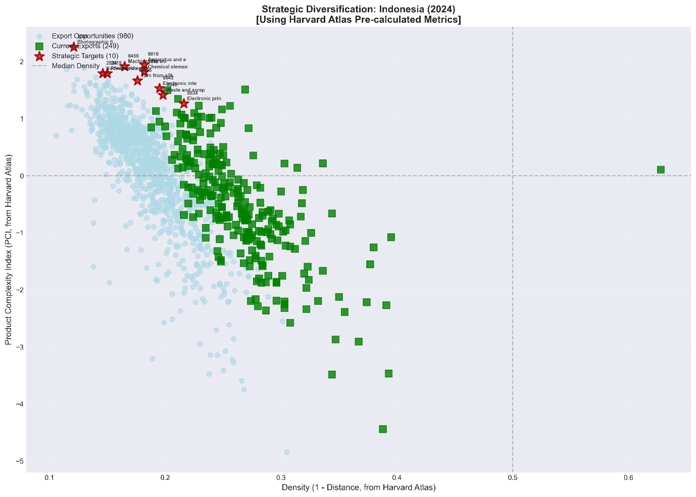

Figure 2 maps Indonesia’s 2024 diversification landscape by plotting feasibility (Density = 1 − Distance, x-axis) against product sophistication (PCI, y-axis) using Harvard Atlas pre-calculated metrics. The current export basket (green squares) is concentrated in the mid-density region but predominantly at low to medium PCI, indicating that existing comparative advantages largely sit in relatively accessible yet less complex products. In contrast, the cloud of export opportunities (light-blue points) spans a wide range of PCI at generally modest densities, reflecting many potential moves but with uneven reachability. The strategic targets (red stars) cluster above the median PCI while often lying at or below the median density, highlighting the core policy trade-off: the products with the largest potential capability gains tend to be farther from Indonesia’s current capability set and therefore unlikely to emerge through passive evolution. This pattern supports a “bridge-building” interpretation—progress toward higher-complexity activities requires deliberate sequencing through intermediate, capability-adjacent steps (raising density) while selectively investing in a small set of high-PCI bets to shift the export structure upward over time.

The strategic portfolio exhibits several distinctive characteristics. First, the average PCI of target products is 1.741, representing a complexity uplift of +2.264 relative to current exports. This magnitude of transformation, if achieved, would significantly reposition Indonesia within the global complexity distribution. Second, average density of 0.173 indicates limited but non-negligible proximity to Indonesia's existing RCA basket; it should be interpreted as a relative feasibility score rather than a literal share of required capabilities, but the magnitude suggests that targeted intervention could bridge the gap. Third, average Complexity Outlook Gain of 0.336 demonstrates meaningful stepping-stone potential, meaning successful entry would significantly improve access to additional complex products.

The top-ranked opportunity is photographic laboratory apparatus (HS 9010), with PCI of 1.949 and strategic score of 0.355. These precision instruments serve semiconductor lithography and optical manufacturing, representing upstream enablers for multiple high-tech industries. Chemical elements for electronics (HS 3818) ranks second, directly supporting semiconductor fabrication processes. Machines for working materials by laser (HS 8456, PCI: 1.916) reflect advanced manufacturing capabilities transferable to precision engineering and aerospace applications.

Electronic integrated circuits (HS 8542, PCI: 1.532) and electronic printed circuits (HS 8534, PCI: 1.267) are particularly significant given Indonesia's ambitions in semiconductor manufacturing. Together with waste and scrap of batteries (HS 8548, PCI: 1.414), these products directly support the electronics value chain strategy that has proven successful in Malaysia and Vietnam, providing a pathway from assembly operations to component manufacturing and eventually design capabilities.

Applying the policy-salience filter described in section 3.3 to the model-ranked portfolio flags two products for exclusion from the policy-adjusted target list. Yarn from silk waste (HS 5005, rank 5) scores a COG of 0.000, indicating zero stepping-stone value: acquiring this product would not improve Indonesia’s access to additional complex products, undermining its rationale as a strategic priority despite its high PCI and robust-core status in the sensitivity analysis. Photographic film, developed (HS 3705, rank 8) relies on a technology trajectory in structural decline—global demand for silver-halide photographic film has contracted sharply since digital imaging displaced analogue processes—making sustained export growth implausible regardless of Indonesia’s capability position. Both products remain in Table 4 and in the sensitivity analysis (section 4.6) as model outputs, but the policy-adjusted strategic targets that inform the Discussion consist of the remaining eight products. Photographic laboratory apparatus (HS 9010) is retained despite its HS label because, as noted in the caveat (section 3.5), the trade code proxies semiconductor lithography and precision optical equipment rather than legacy darkroom apparatus.
The feasibility metrics reveal the challenge inherent in this transformation agenda. The average density of 0.173 indicates limited connection to current capabilities, while the average distance of 0.827 confirms substantial capability gaps. These metrics underscore that organic growth alone cannot achieve the identified targets; instead, strategic intervention through foreign direct investment attraction, special economic zones, and targeted capability building is essential.

Table 4 Top 10 Strategic Opportunity Targets
Rank | HS Code | Product Name | PCI | Density | COG | Distance | Score
1 | 9010 | Photographic lab apparatus | 1.949 | 0.182 | 0.366 | 0.818 | 0.355
2 | 3818 | Chemical elements for electronics | 1.821 | 0.182 | 0.407 | 0.818 | 0.331
3 | 8456 | Laser working machines | 1.916 | 0.165 | 0.427 | 0.835 | 0.316
4 | 8542 | Electronic integrated circuits | 1.532 | 0.195 | 0.376 | 0.805 | 0.299
5 | 5005 | Yarn from silk waste | 1.668 | 0.176 | 0.000 | 0.824 | 0.294
6 | 8548 | Waste/scrap of batteries | 1.414 | 0.198 | 0.372 | 0.802 | 0.280
7 | 8534 | Electronic printed circuits | 1.267 | 0.216 | 0.335 | 0.784 | 0.274
8 | 3705 | Photographic film, developed | 2.256 | 0.121 | 0.333 | 0.879 | 0.273
9 | 2919 | Phosphoric esters | 1.793 | 0.150 | 0.394 | 0.850 | 0.269
10 | 2934 | Nucleic acids and their salts | 1.794 | 0.146 | 0.349 | 0.854 | 0.262

Product Space Positioning

Visualization of the Product Space network (Figure 3) reveals the distribution of Indonesia's current exports (concentrated in the resource-based periphery) and strategic targets (positioned as bridges to the manufacturing core). The identified targets are not randomly distributed but cluster into coherent industrial ecosystems, suggesting the potential for coordinated policy intervention.

Figure 3 Indonesia’s Product Space Network Visualization
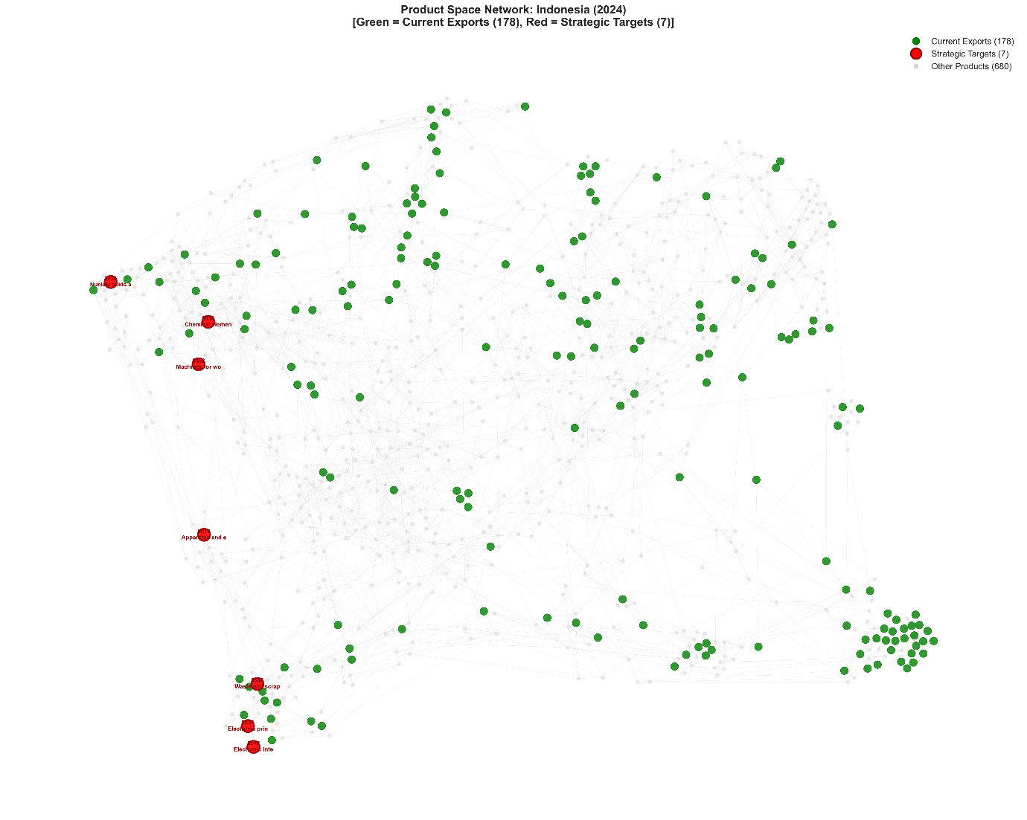

Three strategic pillars emerge from the clustering analysis. Advanced Materials and Chemicals (Pillar A) includes chemical elements for electronics (HS 3818, PCI: 1.821), phosphoric esters (HS 2919, PCI: 1.793), and nucleic acids and their salts (HS 2934, PCI: 1.794). These upstream enablers serve multiple high-tech sectors and represent critical inputs for semiconductor manufacturing, pharmaceutical synthesis, and advanced materials production. The presence of electronic-grade chemicals directly supports semiconductor ecosystem development.

Precision Manufacturing and Equipment (Pillar B) encompasses photographic laboratory apparatus (HS 9010, PCI: 1.949) and machines for working materials by laser (HS 8456, PCI: 1.916). Laser working machines, in particular, represent advanced manufacturing capabilities transferable to precision engineering, aerospace, and medical device production. This pillar builds foundational capabilities that enable subsequent entry into semiconductor equipment and other advanced manufacturing sectors.

Micro-Electronics (Pillar C) includes electronic integrated circuits (HS 8542, PCI: 1.532), electronic printed circuits (HS 8534, PCI: 1.267), and waste and scrap of batteries (HS 8548, PCI: 1.414). The presence of both integrated and printed circuits as strategic targets, despite relatively high distance metrics (0.805 and 0.784 respectively), reflects the scoring framework's recognition of stepping-stone value. This cluster indicates a potential pathway toward vertical integration in electronics manufacturing, from PCB assembly through component production.

Robustness Check: Temporal Stability Analysis
To assess the temporal stability of the strategic portfolio, we replicate the strategic scoring analysis using 2023 trade data from the Harvard Atlas of Economic Complexity. This robustness check examines whether the identified diversification targets reflect persistent structural opportunities or are artefacts of a single year's trade patterns. If the strategic portfolio is robust, the core product targets should remain consistent across adjacent time periods despite year-to-year fluctuations in trade volumes and revealed comparative advantages.

Indonesia's economic position in 2023 provides the comparison baseline. The calculated ECI of 0.284 placed Indonesia at rank 93 out of 230 economies, with export diversity spanning 233 products at RCA ≥ 1.0 and an average PCI of current exports at −0.489. The 2023 scoring exercise yields a strategic portfolio with average target PCI of 1.871, average COG of 0.436, average density of 0.165, and average distance of 0.835. These aggregate metrics closely mirror the 2024 baseline values (average PCI: 1.741, COG: 0.336, density: 0.173, distance: 0.827), with the higher average PCI in 2023 reflecting slightly different product rankings rather than a fundamentally different opportunity set.

The product-level comparison reveals strong consistency. Eight of the ten strategic targets identified using 2024 data also appear in the 2023 top-ten portfolio: photographic laboratory apparatus (HS 9010), chemical elements for electronics (HS 3818), laser working machines (HS 8456), electronic integrated circuits (HS 8542), nucleic acids and their salts (HS 2934), waste and scrap of batteries (HS 8548), electronic printed circuits (HS 8534), and photographic film (HS 3705). This 80 percent overlap rate provides strong evidence that the strategic portfolio captures persistent structural opportunities rather than transient trade fluctuations. Table 5 presents the 2023 strategic targets for direct comparison with Table 4.

Table 5 Top 10 Strategic Opportunity Targets (2023 Data)
Rank | HS Code | Product Name | PCI | Density | COG | Distance | Score
1 | 9010 | Photographic lab apparatus | 2.212 | 0.172 | 0.404 | 0.828 | 0.380
2 | 3818 | Chemical elements for electronics | 2.030 | 0.176 | 0.447 | 0.824 | 0.357
3 | 8456 | Laser working machines | 2.074 | 0.154 | 0.506 | 0.846 | 0.319
4 | 8542 | Electronic integrated circuits | 1.515 | 0.199 | 0.392 | 0.801 | 0.301
5 | 2934 | Nucleic acids and their salts | 1.928 | 0.150 | 0.478 | 0.850 | 0.289
6 | 8548 | Waste/scrap of batteries | 1.573 | 0.179 | 0.432 | 0.821 | 0.282
7 | 8534 | Electronic printed circuits | 1.303 | 0.209 | 0.350 | 0.791 | 0.272
8 | 8475 | Machines for assembling electric lamps | 1.765 | 0.154 | 0.507 | 0.846 | 0.272
9 | 2850 | Hydrides, nitrides, azides | 1.983 | 0.137 | 0.479 | 0.863 | 0.272
10 | 3705 | Photographic film, developed | 2.323 | 0.116 | 0.360 | 0.884 | 0.269

The 2023 analysis also reveals instructive differences in the Complexity Outlook Gain dimension. The top five products by COG in 2023 are screws and similar articles of iron or steel (HS 7318, COG: 0.615), industrial electric furnaces (HS 8514, COG: 0.612), nitrile-function compounds (HS 2926, COG: 0.577), electric soldering machines (HS 8515, COG: 0.571), and instruments for physical or chemical analysis (HS 9027, COG: 0.565). Notably, none of these COG-leaders overlap with the score-ranked top ten in either year, because the strategic scoring function penalises products with very high distance even when their COG is attractive. This divergence illustrates the tension between gateway value and near-term feasibility that the scoring framework is designed to mediate.

The two products that differ between the 2023 and 2024 portfolios are themselves informative. Yarn from silk waste (HS 5005) and phosphoric esters (HS 2919), present in the 2024 portfolio but absent in 2023, are replaced by machines for assembling electric lamps (HS 8475, PCI: 1.765) and hydrides, nitrides, azides, silicides and borides (HS 2850, PCI: 1.983). Both substitutions occur in the same broad capability clusters—precision manufacturing and advanced chemicals—confirming that the sectoral direction is stable even when individual product rankings shift at the margin. The substitution pattern suggests that the three strategic pillars identified in section 4.4 (Advanced Materials and Chemicals, Precision Manufacturing and Equipment, and Micro-Electronics) are robust structural features of Indonesia’s opportunity landscape, not artefacts of a particular year’s trade data.

At the aggregate level, the complexity uplift potential—the gap between average target PCI and average current-export PCI—is +2.359 in 2023 versus +2.264 in 2024, a difference of less than 5 percent. Average distance is similarly stable at 0.835 (2023) versus 0.827 (2024), as is average density at 0.165 versus 0.173. The consistency of these metrics across the two periods reinforces the interpretation that Indonesia faces a persistent structural challenge: the most rewarding diversification targets lie at a stable distance from its current capability set, requiring sustained policy intervention rather than marginal adjustments.

Sensitivity Analysis: Scoring Weight Variation
The baseline strategic score (PCI × Density) implicitly assigns equal weight to product complexity and feasibility. To test the sensitivity of the portfolio ranking to this assumption, we generalise the scoring function to Score(a) = PCI^a × Density^(1−a), where a ∈ [0, 1] governs the complexity–feasibility trade-off. At low a (e.g. 0.3) the score rewards products that are close to Indonesia’s current capability set; at high a (e.g. 0.7) it rewards products with the greatest complexity payoff regardless of distance. The baseline corresponds to a = 0.5. Because fractional powers of negative numbers are undefined in the reals, this analysis is restricted to the PCI > 0 subset of the opportunity space (as specified in section 3.3); products with PCI ≤ 0 are excluded from the sensitivity exercise but are not plausible complexity-upgrading targets in any case. We evaluate five scenarios (a = 0.3, 0.4, 0.5, 0.6, 0.7) and record the top-ten portfolio under each.

Five products appear in the top ten under all five weighting scenarios, forming a model-ranked robust core that is insensitive to the complexity–feasibility balance: photographic laboratory apparatus (HS 9010), chemical elements for electronics (HS 3818), machines for working materials by laser (HS 8456), electronic integrated circuits (HS 8542), and yarn from silk waste (HS 5005). However, HS 5005’s COG of 0.000 means it offers no stepping-stone value—its robust-core status reflects high PCI and moderate density but not pathway-opening potential, and it is accordingly excluded from the policy-adjusted target list (see section 4.3). The policy-adjusted robust core therefore consists of four products: HS 9010, HS 3818, HS 8456, and HS 8542. Of these, HS 9010 ranks first in every scenario, reflecting its combination of high PCI (1.949) and above-average density (0.182). Table 6 presents the full top-ten portfolio under each a scenario.

Table 6 Top-10 Strategic Targets by a Scenario [Score(a) = PCI^a x Density^(1-a)]
Rank | a = 0.3 (feasibility) | a = 0.4 | a = 0.5 (baseline) | a = 0.6 | a = 0.7 (complexity)
1 | 9010: Photographic lab apparatus | 9010: Photographic lab apparatus | 9010: Photographic lab apparatus | 9010: Photographic lab apparatus | 9010: Photographic lab apparatus
2 | 8523: Sound storage media | 3818: Chemical elements for electronics | 3818: Chemical elements for electronics | 3818: Chemical elements for electronics | 3705: Photographic film, developed
3 | 8534: Electronic printed circuits | 8542: Electronic integrated circuits | 8456: Laser working machines | 8456: Laser working machines | 8456: Laser working machines
4 | 3818: Chemical elements for electronics | 8456: Laser working machines | 8542: Electronic integrated circuits | 3705: Photographic film, developed | 3818: Chemical elements for electronics
5 | 8542: Electronic integrated circuits | 8534: Electronic printed circuits | 5005: Yarn from silk waste | 5005: Yarn from silk waste | 2919: Phosphoric esters
6 | 8548: Waste/scrap of batteries | 8548: Waste/scrap of batteries | 8548: Waste/scrap of batteries | 8542: Electronic integrated circuits | 5005: Yarn from silk waste
7 | 5005: Yarn from silk waste | 5005: Yarn from silk waste | 8534: Electronic printed circuits | 2919: Phosphoric esters | 8113: Cermets
8 | 8456: Laser working machines | 8523: Sound storage media | 3705: Photographic film, developed | 2934: Nucleic acids and their salts | 2934: Nucleic acids and their salts
9 | 8473: Parts/accessories for office machines | 2935: Sulfonamides | 2919: Phosphoric esters | 8113: Cermets | 8542: Electronic integrated circuits
10 | 9110: Clock movements, complete | 2919: Phosphoric esters | 2934: Nucleic acids and their salts | 8548: Waste/scrap of batteries | 7221: Bars of stainless steel, hot-rolled

Beyond the robust core, eleven additional products enter or exit the top ten as the weighting parameter shifts, yielding a total sensitivity pool of sixteen products. The rank-switching pattern is systematic rather than random. Low-a scenarios (a = 0.3, 0.4) favour near-term feasibility targets with high density: sound storage media (HS 8523, density: 0.228), electronic printed circuits (HS 8534, density: 0.216), and parts and accessories for office machines (HS 8473, density: 0.199) enter the top ten only when feasibility is weighted heavily. High-a scenarios (a = 0.6, 0.7) favour ambitious complexity bets: photographic film (HS 3705, PCI: 2.256), cermets (HS 8113, PCI: 1.891), and bars of stainless steel (HS 7221, PCI: 1.725) appear only when complexity payoff dominates. Waste and scrap of batteries (HS 8548) and phosphoric esters (HS 2919) display partial overlap, appearing in four of five scenarios, indicating semi-robust status.

Figure 4 Sensitivity Analysis: Rank Stability and PCI-Density Positioning across a Scenarios

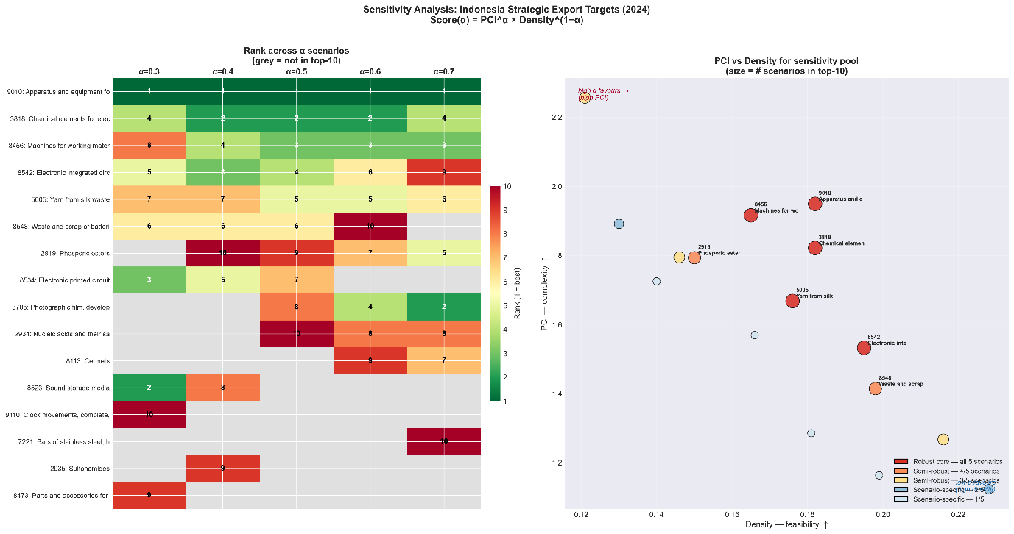
Figure 4 plots the sensitivity pool in PCI-Density space, with point size proportional to the number of scenarios in which each product appears. The robust core (red, present in all five scenarios) occupies a band of moderate-to-high PCI (1.5–2.0) and moderate density (0.165–0.195), confirming that the most stable strategic targets are those that balance complexity and feasibility rather than maximising either dimension in isolation. The scenario-specific products (appearing in one or two scenarios) scatter toward the extremes: high-density/low-PCI in the bottom-right (feasibility-driven) and high-PCI/low-density in the top-left (complexity-driven). This spatial distribution validates the scoring framework’s design—the baseline a = 0.5 selects products from the interior of the opportunity set, avoiding both the over-cautious trap of incremental upgrades and the over-ambitious trap of unattainable complexity jumps.

The sensitivity analysis carries direct policy implications. The four policy-adjusted robust-core products—photographic laboratory apparatus, chemical elements for electronics, laser working machines, and electronic integrated circuits—should constitute the first-priority targets for industrial policy, as their strategic value is invariant to the policymaker’s relative emphasis on ambition versus pragmatism. The semi-robust products (waste and scrap of batteries, phosphoric esters) merit secondary-priority support. The scenario-specific products offer a policy menu contingent on strategic posture: a risk-averse policymaker would add the high-density, low-a products (sound storage media, electronic printed circuits) for near-term wins, while a transformative agenda would add the high-PCI, high-a products (photographic film, cermets) for maximum long-term complexity gains.

Discussion

The Complexity Gap and Its Implications

The findings expose a mismatch: Indonesia has the scale and resource base of a major emerging market but the complexity profile of a resource-dependent economy. The +2.264 PCI gap between current exports and strategic targets—confirmed at +2.359 using 2023 data (section 4.5) and invariant to scoring weight assumptions across five complexity–feasibility scenarios (section 4.6)—is not just a number — it implies a qualitative shift in what the economy produces and how. The sensitivity analysis further demonstrates that the strategic portfolio contains a model-ranked five-product robust core, of which four survive the policy-salience filter (photographic laboratory apparatus, chemical elements for electronics, laser working machines, and electronic integrated circuits), providing a stable foundation for policy targeting that is insensitive to the policymaker’s relative emphasis on ambition versus pragmatism.

This complexity gap has direct implications for productivity growth, the essential driver of sustained income convergence. McKinsey & Company (2025) estimates that achieving the Golden Indonesia 2045 vision requires productivity growth acceleration from the current 2% annually to 4.9% annually. Historical evidence from successful structural transformers - South Korea, Taiwan, and more recently Vietnam - demonstrates that such acceleration is achievable only through sustained diversification into increasingly complex activities that generate learning-by-doing, knowledge spillovers, and capability accumulation.

The downstreaming paradox is visible here. Current industrial policy has successfully increased export values but has not generated the capability foundations for continued upgrading. Nickel processing remains concentrated in intermediate stages (ferronickel, nickel pig iron) that, while profitable, do not develop the specialized chemicals, precision engineering, and semiconductor-related capabilities that the strategic scoring analysis identifies as strategic priorities.

Operationalizing the 4W Framework
This section interprets the results through Hidalgo's 4W policy framework, addressing What products to target, When to sequence interventions, Where to locate investments, and Who should drive implementation. We also examine binding constraints and the relationship between our recommendations and Indonesia's current industrial policy priorities.

What: Sectoral Priorities

The strategic scoring results translate into five actionable sectoral priorities that align with Indonesia's existing industrial base while targeting complexity upgrading. Critically, the sensitivity analysis (section 4.6) allows these priorities to be tiered by confidence level. The five robust-core products—stable across all weighting scenarios—cluster in electronics and advanced chemicals, identifying these as first-priority sectors. Semi-robust products (waste and scrap of batteries, phosphoric esters) support the advanced metals and chemicals agenda as secondary priorities. Scenario-specific products offer a contingent policy menu: feasibility-weighted scenarios add near-term targets such as sound storage media and electronic printed circuits, while complexity-weighted scenarios add ambitious bets such as cermets and hot-rolled stainless steel bars.
Electronics, specifically Outsourced Semiconductor Assembly and Test (OSAT), is the highest-potential sector given global supply chain restructuring and Indonesia's proximity to established semiconductor hubs in Singapore and Malaysia. The target products identified in Table 4 (electronic integrated circuits, chemical elements for electronics, electronic printed circuits) provide a clear entry pathway. This sector's primacy is reinforced by the sensitivity analysis: three of the five robust-core products (electronic integrated circuits, chemical elements for electronics, and photographic laboratory apparatus) belong to this cluster, and electronic printed circuits enters the top ten under feasibility-weighted scenarios (a ≤ 0.4), confirming that the electronics pathway is strategically sound regardless of how the policymaker balances ambition against near-term feasibility.

Advanced Metals processing represents a natural evolution from current downstreaming activities. Rather than remaining at the ferronickel stage, the strategic priority should shift toward battery precursors, cathode materials, and specialized alloys with PCI values exceeding 1.2. This transition leverages Indonesia's 42% global share of nickel reserves while generating substantially higher complexity. The sensitivity analysis positions waste and scrap of batteries (HS 8548) as a semi-robust target, appearing in four of five weighting scenarios, while cermets (HS 8113) and hot-rolled stainless steel bars (HS 7221) emerge only under complexity-weighted scenarios (a ≥ 0.6). This pattern suggests that battery recycling and precursor manufacturing are robust near-term priorities within this sector, whereas advanced alloy production represents a higher-risk, higher-payoff bet contingent on stronger capability accumulation.

Machinery and Industrial Equipment is the "unrelated bet" with the highest long-term payoff. The presence of laser working machines (HS 8456, PCI: 1.916) and photographic laboratory apparatus (HS 9010, PCI: 1.949) among strategic targets indicates an opportunity to develop indigenous industrial equipment capabilities. Both products belong to the sensitivity analysis's robust core—HS 9010 ranks first under all five weighting scenarios—meaning this sector's strategic value persists even under heavily feasibility-weighted assumptions that penalise unrelated diversification. This sector generates particularly strong backward linkages and capability spillovers across manufacturing.

Automotive and EV Manufacturing builds on Indonesia's domestic market scale and emerging EV policy framework. The ASEAN EV production hub ambition requires integration with the advanced metals and electronics sectors identified above, creating opportunities for vertical integration and ecosystem development.

Agro-Processing is the most feasible diversification pathway. The shift from crude palm oil to oleochemicals, biofuels, and specialized derivatives (medical rubber gloves, technical tires) offers immediate complexity gains with relatively low capability requirements. This sector provides early wins that can build momentum for more ambitious transformation efforts.

When: Phased Implementation

The demographic window creates urgency for implementation. Indonesia's working-age population share peaks in 2031, providing approximately six years to generate manufacturing employment before the dependency ratio begins rising. This timeline necessitates a phased approach that balances immediate employment generation with long-term capability building.

Phase 1 (Foundation, 2025-2027) should allocate approximately 70% of policy support toward related diversification that leverages existing capabilities. Immediate priorities include agro-processing enhancements, completion of nickel downstreaming with explicit planning for Phase 2 battery chemical transitions, and reinvigoration of underutilized textile capacity for technical textile production. This phase should also establish pilot special economic zones for electronics and machinery, with aggressive anchor investor attraction. The sensitivity analysis provides an empirical basis for sequencing within this phase: the five robust-core products and two semi-robust products (section 4.6) should anchor early policy support, as their strategic value is invariant to assumptions about the complexity–feasibility trade-off. Feasibility-weighted targets such as sound storage media (HS 8523) and parts for office machines (HS 8473), which enter the portfolio only at a ≤ 0.4, offer additional near-term wins that can generate early employment and build institutional confidence for more ambitious interventions.

Phase 2 (Scaling, 2027-2030) shifts the balance toward 50-50 allocation between related and unrelated diversification, consistent with the theoretical optimum for intermediate-complexity economies identified by Alshamsi et al. (2018). Successful pilots should scale up, supplier linkages to anchor firms should be actively fostered, and existing sectors should be pushed further up the value chain. The transition from basic nickel processing to battery materials manufacturing should be operationalized during this phase.

Phase 3 (Innovation, 2030-2045) deepens capabilities in established complex industries, moving toward design, R&D, and original brand manufacturing. The balance may shift toward 40% related and 60% unrelated diversification as new capabilities are established. The complexity-weighted targets from the sensitivity analysis—cermets (HS 8113), hot-rolled stainless steel bars (HS 7221), and nucleic acids and their salts (HS 2934), which enter the portfolio only at elevated complexity weighting—represent the appropriate targets for this phase, as they offer the highest long-term complexity payoff but require the deepest capability base. Indonesia should position as a regional hub for select high-complexity sectors, leveraging accumulated capabilities and scale advantages.

Where: Geographic Specialization

Effective industrial policy requires transforming generalist industrial parks into specialized thematic clusters that concentrate capabilities, foster knowledge spillovers, and achieve agglomeration economies. We propose four geographic focal points aligned with the strategic pillars

The Digital and Semiconductor Hub should be established in Batam or the Riau Islands, leveraging Singapore's proximity for knowledge spillovers, OSAT capabilities, and semiconductor materials and equipment access. This location offers established infrastructure, skilled workforce availability, and established trade linkages.

The Green Battery Valley should be centered in Central Sulawesi near existing nickel processing facilities, enabling integrated development from battery materials through cell manufacturing to vehicle assembly. Renewable energy supply is critical for this location to meet ESG requirements for EU and US market access.

The Bio-Industry Corridor in Sumatra should focus on palm oil derivatives, advanced oleochemicals, rubber products, and food processing, leveraging the region's agricultural base and established supply chains.

The High-Tech Belt in Java should concentrate industrial equipment manufacturing, automotive production, software development, fintech, and R&D centers, building on the island's human capital advantages and infrastructure density.

Who: Institutional Orchestration

Effective implementation requires coordinated action across multiple institutional actors. The government must serve as orchestrator, establishing a high-level complexity task force with authority to break ministerial silos, align incentives across agencies, and coordinate policy implementation. This body should report directly to the President and have operational control over relevant incentive programs.

The private sector constitutes the transformation engine. Domestic conglomerates must be incentivized to pivot from commodity extraction and trading toward manufacturing and value creation. Foreign anchor firms are essential for technology transfer, particularly in electronics and machinery sectors where Indonesia lacks indigenous capabilities.

Academic institutions serve as catalysts, requiring fundamental restructuring of vocational and higher education to align with specific industrial needs. Battery technology schools in Sulawesi, semiconductor training centers in Batam, and precision engineering programs in Java should be established with mandatory internship arrangements with SEZ anchor investors.

State-Owned Enterprises (SOEs) can serve as enablers through targeted de-risking of early-stage investments. Traditional SOEs and private conglomerates are well positioned to advance Pillar A's near-capability diversification—extending nickel downstreaming into battery precursors or scaling OSAT assembly—because these activities lie close to competences they already possess. However, neither class of actor has the technical mandate or risk tolerance to venture into the unrelated bets that drive the highest long-term complexity gains. Precision machinery (HS 8456, HS 9010), advanced alloys such as cermets (HS 8113), and other Pillar B targets sit far from Indonesia's current product-space core; they require patient capital, tolerance for multi-year negative returns, and the ability to absorb technology-transfer costs that conventional balance sheets cannot justify to shareholders or line ministries.
Danantara is institutionally designed to fill this gap. As a sovereign wealth fund with assets under management exceeding USD 900 billion and an initial strategic investment envelope of USD 20 billion (ASEAN Briefing, 2025), it operates outside the quarterly-earnings logic of listed conglomerates and the bureaucratic risk aversion of sectoral SOEs. Three mechanisms make it a targeted de-risking catalyst for the unrelated-diversification agenda. First, Danantara can provide first-loss equity in greenfield precision-machinery ventures, absorbing downside risk that crowds in private co-investors once technical viability is demonstrated. Second, it can anchor joint ventures with foreign technology partners—particularly the US and European firms incentivised under the February 2026 trade framework—offering them a creditworthy local counterparty with sovereign backing rather than fragmented SME partners. Third, by consolidating oversight of relevant SOE subsidiaries, Danantara can coordinate capability sequencing across the phased timeline outlined in section 5.2.2: directing early-phase investments toward near-capability OSAT and battery materials while simultaneously seeding the longer-horizon machinery and industrial-equipment programmes that the sensitivity analysis identifies as robust across all weighting scenarios.
Development Finance Institutions complement Danantara by providing concessional debt for infrastructure and working-capital facilities in the SEZs designated for these priority sectors, ensuring that the de-risking architecture extends from equity through to project finance.

Addressing Binding Constraints

The transformation agenda faces two primary binding constraints that must be addressed for successful implementation. Logistics costs currently consume 24% of GDP compared to 14% in Thailand, representing a fundamental competitiveness disadvantage. Port inefficiency at Tanjung Priok and connectivity gaps between production centers and export facilities create friction that undermines manufacturing competitiveness. Acceleration of the National Logistics Ecosystem (NLE) and prioritized investment in Patimban port development are essential infrastructure priorities.

The human capital gap is equally serious. Ninety percent of Indonesia's workforce lacks formal training, and labor productivity at USD 14 per hour significantly lags regional peers. The transformation agenda requires massive scale-up of vocational training aligned with sector-specific needs, including the proposed Battery Technology Academy in Sulawesi and semiconductor engineering programs. Diaspora return programs should target experienced professionals for strategic unrelated diversification jumps.

The green energy nexus adds a third constraint with growing strategic importance. ESG scrutiny increasingly determines market access, and nickel downstreaming must address carbon intensity and waste management to maintain access to EU and US markets. Decoupling industrial parks from coal and investing in battery energy storage systems and renewables for special economic zones will ensure global compliance while positioning Indonesia favorably in the emerging clean technology value chains.

Political Economy of Downstreaming and Geopolitical Pressures

The preceding analysis assumes that export diversification is primarily a capability-building problem. In practice, Indonesia's transformation pathway is deeply embedded in a political economy shaped by resource nationalism, great-power competition over critical minerals, and evolving trade law constraints. These forces interact with—and in some cases override—the economic logic of complexity upgrading, making any diversification strategy contingent on how Jakarta navigates an increasingly contested geopolitical landscape.

Indonesia's nickel downstreaming policy, initiated through the 2009 Mining Law and culminating in the full ore export ban of January 2020, has delivered impressive headline results. Nickel export values surged from approximately USD 1 billion to USD 20 billion within two years, and the country's share of global mined nickel production rose from 31.5% in 2020 to over 60% by 2024 (S&P Global Market Intelligence, 2025). FDI inflows into downstream processing triggered a wave of smelter construction, industrial park development, and the emergence of battery precursor manufacturing. Yet the ownership structure reveals a critical tension: Indonesian firms control only around 10% of the country's refined nickel capacity, while Chinese companies—principally Tsingshan, Huayou, CNGR, and GEM—account for approximately 65–75% through control of industrial parks at Morowali (IMIP), Weda Bay, and Pomalaa (Manini, 2025; Zongzhe Li, 2025). This concentration means that downstreaming has built Chinese-controlled capacity in Indonesia rather than Indonesian industrial capacity per se, raising questions about whether the policy generates the indigenous capability accumulation that our complexity framework identifies as essential for sustained upgrading.

The geopolitical dimension has sharpened considerably since 2022. The WTO dispute panel in DS592 ruled that Indonesia's export ban and domestic processing requirements are inconsistent with GATT Article XI:1, a finding that Indonesia has effectively suspended by filing an appeal to the non-functioning Appellate Body (WTO, 2022). However, the legal space for downstreaming instruments continues to narrow. The EU–Indonesia Comprehensive Economic Partnership Agreement, agreed in September 2025, includes explicit disciplines against export restrictions on raw materials. More consequentially, the US–Indonesia Reciprocal Trade Agreement finalised in February 2026 commits Indonesia to remove export restrictions on critical minerals destined for the United States, while maintaining a 19% reciprocal tariff on Indonesian goods (White House, 2026). Under this agreement, Indonesia pledged to promote US investment across its mineral industry with treatment "no less favourable" than domestic firms. Each successive framework constrains the very policy instruments—export bans, domestic processing requirements, and differentiated licensing—that underpin the downstreaming strategy.

Indonesia's response to these pressures reflects a pragmatic hedging strategy rather than ideological alignment. President Prabowo Subianto's administration has sought to maintain the substance of downstreaming while adjusting its form. The February 2026 trade agreement with the US was framed domestically not as an abandonment of the export ban but as an agreement concerning processed industrial products rather than raw ore, preserving the narrative of value-added sovereignty. Simultaneously, Jakarta has deepened institutional capacity through the establishment of Danantara (Daya Anagata Nusantara) in February 2025, a sovereign wealth fund with assets under management exceeding USD 900 billion, tasked with consolidating state-owned enterprise management and directing initial investments of USD 20 billion into nickel, bauxite, copper processing, renewable energy, and related strategic industries (ASEAN Briefing, 2025). Danantara represents an attempt to shift the state's role from regulator to strategic investor, potentially providing an alternative mechanism for directing industrial upgrading when trade-law-compatible instruments replace blunt export prohibitions.

On the production side, the government has adopted supply management as a complementary policy lever. The 2026 RKAB (mining quota) allocation was set at 270 million wet metric tonnes, down sharply from 375 million in 2025 and below the estimated demand of 345 million tonnes (Hughes, 2026). Combined with the shift from flat-rate to progressive royalties announced in March 2025 and the February 2025 mandate requiring foreign exchange earnings from minerals to remain in the domestic banking system for one year, these measures represent a recalibration from volume-driven expansion toward value extraction and resource conservation. The production tightening, coupled with a Chinese sulphuric acid export ban and declining ore grades, contributed to a 37% LME nickel price rally from late December 2025 to April 2026, with the International Nickel Study Group revising its 2026 balance from a 283,000-tonne surplus to a 32,000-tonne deficit.

These political economy dynamics carry direct implications for the diversification strategy proposed in this paper. First, the complexity upgrading pathway depends on whether Indonesia can transition from blunt export prohibitions to more sophisticated industrial policy instruments—targeted investment incentives, capability-building programs, and green energy mandates—that achieve the same upgrading objectives while remaining WTO-compatible and trade-agreement-compliant. Second, reducing dependence on Chinese capital and technology in the nickel value chain requires proactive diversification of investment sources, including the US partnership mechanisms embedded in the February 2026 trade deal and Danantara's role in de-risking early-stage ventures for non-Chinese investors. Third, the environmental sustainability of downstreaming has become a market-access imperative: the EU's Critical Raw Materials Act (2024) caps any single third-country supplier share at 65% and sets domestic processing benchmarks, while the EU Carbon Border Adjustment Mechanism (CBAM) penalises carbon-intensive imports. Indonesia's heavy reliance on captive coal power for nickel smelting creates a structural vulnerability that the green energy constraint identified in section 5.3 will increasingly determine whether Indonesian processed minerals retain access to premium Western markets.

The complexity framework advanced in this paper remains analytically robust, but its implementation is inseparable from these geopolitical and institutional realities. A diversification strategy that ignores the political economy of resource governance risks prescribing optimal products without accounting for whether the enabling policy environment can be sustained. The phased approach outlined in section 5.2.2 must therefore be understood not merely as a capability-sequencing exercise but as a political negotiation across multiple fronts: with trading partners seeking raw material access, with Chinese investors whose capital built the current processing infrastructure, with domestic constituencies demanding employment and environmental accountability, and with international institutions whose rules constrain the available policy toolkit.

Implementation Risks

The diversification strategy proposed in this paper faces several implementation risks that merit explicit consideration. These risks span institutional coordination failures, market and technology uncertainties, political sustainability challenges, and external shocks that could derail or distort the transformation pathway.

Institutional fragmentation poses the most immediate risk. The 4W framework (section 5.2) presupposes a high-level complexity task force with cross-ministerial authority, yet Indonesia's bureaucratic landscape is characterised by overlapping jurisdictions, competing mandates, and weak horizontal coordination. The Ministry of Industry, the Ministry of Energy and Mineral Resources, the Investment and Downstream Industry Ministry, and now Danantara each hold partial authority over the industrial upgrading agenda. Historical experience with cross-cutting coordination bodies—including the National Economic Committee under previous administrations—suggests that such entities struggle to override line-ministry inertia without sustained presidential backing. The risk is that sectoral priorities identified in section 5.2.1 are pursued in isolation rather than as an integrated ecosystem, forfeiting the inter-industry spillovers that justify the complexity-based approach.

Technology lock-in represents a second category of risk. The dominance of Chinese firms in Indonesia's nickel processing has established RKEF (rotary kiln electric furnace) and HPAL (high-pressure acid leaching) as the standard processing pathways. Both technologies are energy-intensive and generate significant waste streams, and both depend on Chinese equipment supply chains—approximately 80–90% of Indonesia's refining machinery imports originate from China (Zongzhe Li, 2025). A transition to higher-complexity products such as battery-grade nickel sulphate and cathode active materials requires different process technologies, quality control regimes, and workforce competencies. The risk is that sunk investments in current processing infrastructure create path dependencies that impede the capability transitions our strategic targets require, particularly if incumbent operators lack incentives to cannibalise existing profitable but lower-complexity production lines.

Market risk arises from the concentration of Indonesia's downstream output in a narrow demand base. China absorbs over 80% of Indonesia's primary nickel exports, and the EV battery value chain—the primary demand driver for higher-value nickel products—remains heavily concentrated in Chinese cell manufacturers (CATL, BYD, EVE Energy). A slowdown in Chinese EV demand growth, accelerated adoption of nickel-free LFP (lithium iron phosphate) battery chemistries, or a geopolitical rupture that disrupts bilateral trade flows could simultaneously depress prices and strand processing capacity. The growing popularity of LFP batteries, which already dominate China's domestic EV market, poses a structural demand risk for nickel-intensive NMC and NCA chemistries on which Indonesia's battery material ambitions are premised. Diversifying the customer base toward European and North American manufacturers is essential but constrained by the carbon intensity and ESG compliance gaps discussed in section 5.3.

Fiscal sustainability constitutes a further risk. The Prabowo administration's growth strategy relies on budget reallocations of approximately USD 44 billion—equivalent to 10% of annual government spending—to fund Danantara and other flagship programmes, including the free school meal initiative. These reallocations have already triggered austerity-driven cuts to public works, education, and regional development budgets. If the diversification strategy requires sustained public investment in infrastructure, vocational training, and special economic zone development over the 2025–2045 horizon outlined in section 5.2.2, fiscal space may prove insufficient—particularly given Indonesia's current account deficit of USD 8.9 billion (0.6% of GDP in 2024) and the absence of a commodity-revenue sovereign wealth fund model comparable to Norway or the Gulf states.

Environmental and social risks threaten both the political legitimacy and market viability of the transformation agenda. Nickel processing in Sulawesi and Maluku has generated documented environmental damage—toxic tailings, freshwater contamination, and deforestation—alongside labour rights concerns, including 107 fatalities in 104 workplace accidents across nickel smelters between 2019 and 2025 (Camarillo, 2025). The rapid expansion of captive coal power plants to serve industrial parks has increased the sector's carbon footprint precisely when EU CBAM implementation and battery passport requirements are tightening green credentials for market access. A high-profile environmental disaster or forced labour scandal in the nickel sector could trigger reputational contagion that undermines Indonesia's positioning across the broader diversification portfolio, including the electronics, automotive, and agro-processing sectors that depend on favourable trade access.

Finally, the risk of policy reversal or inconsistency cannot be discounted. Indonesia's industrial policy has oscillated between liberalisation and resource nationalism across successive administrations—the 2014 export ban was partially relaxed before being reimposed in 2020. The February 2026 US trade agreement's commitment to remove critical mineral export restrictions creates potential tension with the domestic political constituency that views the export ban as a sovereignty assertion. If trade deal implementation requires dismantling the core downstreaming instruments before alternative upgrading mechanisms (investment incentives, Danantara-led co-investments, green energy mandates) are operational, a policy vacuum could stall the transition at precisely the intermediate stage where capability accumulation is most fragile. Managing this sequencing risk—ensuring new instruments are in place before old ones are retired—is arguably the single most consequential implementation challenge for the strategy proposed in this paper.

Conclusions

Growth without complexity is fragile. Despite impressive headline figures—seventh-largest economy, 42 percent of global nickel reserves, USD 35 billion in nickel exports—the economy remains trapped in the low-complexity periphery of the global product space. The current average Product Complexity Index of −0.523 reveals an economy extracting value from natural endowments rather than accumulating the productive capabilities that underpin sustained prosperity. Regional peers have demonstrated that alternative paths exist; Vietnam's electronics-led transformation and Thailand's automotive cluster development illustrate the power of strategic complexity upgrading.

This paper has applied the economic complexity scoring framework to chart a transformation pathway for Indonesia. Four principal findings emerge. First, strategic product selection diverges meaningfully from conventional relatedness-complexity approaches; our strategic targets offer a +2.264 PCI uplift that traditional feasibility-weighted methods would discount. Second, The model-ranked ten targets cluster into coherent industrial ecosystems, while the policy-salience filter yields eight policy-adjusted targets suitable for industrial-policy prioritization. Third, the 4W framework translates quantitative complexity metrics into actionable policy: What products to pursue (electronics, advanced metals, machinery, automotive/EV, agro-processing), When to sequence interventions (three phases aligned with the 2031 demographic peak), Where to locate investments (four specialized clusters leveraging geographic positioning), and Who should drive implementation (coordinated roles for government, private sector, academia, and SOEs). Fourth, robustness and sensitivity analysis confirms that a core set of targets—advanced metals, precision machinery, and select electronics components—remains optimal across a wide range of parameter specifications, while agro-processing targets prove more sensitive to weighting assumptions, reinforcing the case for a phased strategy that front-loads robust-core sectors in Phase 1 and defers complexity-weighted bets to Phase 3.

The binding constraints of logistics costs and human capital deficits require parallel attention; complexity upgrading cannot succeed without the enabling infrastructure and skills that make sophisticated manufacturing viable. The green energy nexus represents both constraint and opportunity—ESG requirements increasingly gate market access, but Indonesia's renewable potential and critical mineral position offer comparative advantage in the clean technology value chains reshaping global industry.

Critically, the diversification strategy cannot be assessed in isolation from the political economy that shapes its implementation. Indonesia's nickel downstreaming experience demonstrates that industrial policy success on headline metrics—export value, FDI inflows, global market share—can coexist with structural vulnerabilities in domestic ownership, technology dependence, and narrowing trade-law space. The WTO ruling in DS592, the EU–Indonesia CEPA disciplines on export restrictions, and the February 2026 US–Indonesia trade agreement collectively constrain the very policy instruments that launched the downstreaming transformation, requiring a transition toward more sophisticated, WTO-compatible industrial policy tools. Implementation risks—institutional fragmentation across ministries, technology lock-in to Chinese processing platforms, fiscal sustainability of investment incentives, and environmental liabilities from coal-powered smelting—constitute binding constraints as consequential as logistics or human capital, and must be addressed through coordinated institutional reform rather than sector-by-sector fixes.

Several limitations warrant acknowledgment. Our analysis relies on merchandise trade data, which may underrepresent complexity in services, digital products, and domestic value chains. The strategic diversification framework assumes that capability proximity adequately captures diversification barriers, potentially understating institutional and political economy constraints. The four-digit HS classification aggregates heterogeneous products, masking within-category complexity variation relevant for fine-grained policy targeting. The analysis focuses on export complexity and does not comprehensively address domestic market opportunities or import substitution possibilities. The sensitivity analysis partially addresses parameter dependence but cannot capture all sources of model uncertainty, including evolving geopolitical conditions and trade-agreement constraints that may shift the feasibility landscape for specific product targets.

Future research should extend this framework in several directions. Incorporation of services complexity metrics would provide a more complete picture of Indonesia's capability profile as the economy digitizes. Sub-national analysis could identify regional variation in complexity trajectories and tailor interventions to local capability endowments. Comparative analysis with successful structural transformers - Vietnam, Thailand, and historical cases such as South Korea and Taiwan - would identify implementation lessons and potential pitfalls. Quantitative modeling of the productivity implications of alternative diversification pathways would strengthen the economic case for policy prioritization. Finally, systematic analysis of how trade-agreement constraints, geopolitical mineral competition, and institutional reform interact with complexity-based diversification strategies would bridge the gap between optimal product selection and implementable industrial policy—a gap that Indonesia's downstreaming experience reveals to be as consequential as the technical challenge of capability accumulation itself.

Reaching Golden Indonesia 2045 demands discipline, not merely ambition. Indonesia has the scale (273 million people), the resources (world-leading nickel, palm oil, and coal), and the geographic position (ASEAN centrality, China+1 beneficiary). What it lacks is know-how: the productive capabilities that turn raw endowments into sophisticated outputs. The strategic roadmap outlined here charts a path from resource supplier toward manufacturing hub, but execution will determine whether Indonesia achieves the 4.9 percent productivity growth that high-income status requires. The complexity transition is not optional; it is how Indonesia moves from exporting commodities to accumulating the capabilities that sustain high-income growth. But as the political economy of nickel downstreaming demonstrates, the transition is as much a negotiation—with trading partners, foreign investors, domestic constituencies, and international institutions—as it is a technical optimisation. The analytical framework presented here identifies where Indonesia should go; whether it gets there depends on the institutional and political capacity to navigate the journey.

References

- Alshamsi, A., Pinheiro, F. L., & Hidalgo, C. A. (2018). Optimal diversification strategies in the networks of related products and of related research areas. Nature Communications, 9(1), 1328. https://doi.org/10.1038/s41467-018-03740-9
- ASEAN Briefing. (2025). Indonesia launches Danantara. ASEAN Briefing, March 10, 2025. https://www.aseanbriefing.com/news/indonesia-officially-launches-new-sovereign-wealth-fund-danantara/
- Bahar, D., Hausmann, R., & Hidalgo, C. A. (2014). Neighbors and the evolution of the comparative advantage of nations: Evidence of international knowledge diffusion. Journal of International Economics, 92(1), 111–123. https://doi.org/10.1016/j.jinteco.2013.11.001
- Balland, P.-A., Boschma, R., Crespo, J., & Rigby, D. L. (2019). Smart specialization policy in the European Union: Relatedness, knowledge complexity and regional diversification. Regional Studies, 53(9), 1252–1268. https://doi.org/10.1080/00343404.2018.1437900
- Camarillo, I. (2025). Trade and critical minerals: The deadly cost of nickel mining in Indonesia. Public Citizen's Global Trade Watch, December 2025. https://gtwaction.org/the-deadly-cost-of-nickel-mining-in-indonesia/
- Chang, H.-J., & Andreoni, A. (2020). Industrial policy in the 21st century. Development and Change, 51(2), 324–351. https://doi.org/10.1111/dech.12570
- Cristelli, M., Gabrielli, A., Tacchella, A., Caldarelli, G., & Pietronero, L. (2013). Measuring the intangibles: A metrics for the economic complexity of countries and products. PLoS ONE, 8(8), e70726. https://doi.org/10.1371/journal.pone.0070726
- Domar, E. D. (1946). Capital expansion, rate of growth, and employment. Econometrica, 14(2), 137–147. https://doi.org/10.2307/1905364
- European Commission. (2024). Regulation (EU) 2024/1252 of the European Parliament and of the Council establishing a framework for ensuring a secure and sustainable supply of critical raw materials (Critical Raw Materials Act). Official Journal of the European Union, L series, May 23, 2024.
- Harrod, R. F. (1939). An essay in dynamic theory. The Economic Journal, 49(193), 14–33. https://doi.org/10.2307/2225181
- Hausmann, R., Hidalgo, C. A., Bustos, S., Coscia, M., Simoes, A., & Yildirim, M. A. (2014). The atlas of economic complexity: Mapping paths to prosperity. MIT Press.
- Hidalgo, C. A. (2023). The policy implications of economic complexity. Research Policy, 52(9), 104825. https://doi.org/10.1016/j.respol.2023.104825
- Hidalgo, C. A., & Hausmann, R. (2009). The building blocks of economic complexity. Proceedings of the National Academy of Sciences, 106(26), 10570–10575. https://doi.org/10.1073/pnas.0900943106
- Hidalgo, C. A., Klinger, B., Barabási, A.-L., & Hausmann, R. (2007). The product space conditions the development of nations. Science, 317(5837), 482–487. https://doi.org/10.1126/science.1144581
- Hughes, W. (2026). Indonesia's 2026 policy tightening has repriced the nickel cost map. Crux Investor, May 16, 2026. https://www.cruxinvestor.com/posts/indonesias-2026-policy-tightening-has-repriced-the-nickel-cost-map
- Juhász, R., & Lane, N. (2024). The political economy of industrial policy. Journal of Economic Perspectives, 38(4), 27–50. https://doi.org/10.1257/jep.38.4.27
- Lee, K., & Malerba, F. (2017). Catch-up cycles and changes in industrial leadership: Windows of opportunity and responses of firms and countries in the evolution of sectoral systems. Research Policy, 46(2), 338–351. https://doi.org/10.1016/j.respol.2016.09.006
- Manini. (2025). Indonesia’s nickel strategy: Downstreaming and development. Observer Research Foundation Expert Speak, October 15, 2025. https://www.orfonline.org/expert-speak/indonesia-s-nickel-strategy-downstreaming-and-development
- McKinsey & Company. (2024). Diversifying global supply chains: Opportunities in Southeast Asia. McKinsey Insights, September 5, 2024. https://www.mckinsey.com/industries/logistics/our-insights/diversifying-global-supply-chains-opportunities-in-southeast-asia
- McKinsey & Company. (2025). The enterprising archipelago: Propelling Indonesia’s productivity. McKinsey Global Institute Report, April 2025. https://www.mckinsey.com/mgi/our-research/the-enterprising-archipelago-propelling-indonesias-productivity
- Oxford Business Group. (2024). Indonesia’s human capital initiatives: Jobs, education and skills. In The Report: Indonesia 2024. Oxford Business Group, October 2024. https://oxfordbusinessgroup.com/reports/indonesia/2024-report/economy/strong-foundation-human-capital-initiatives-take-centre-stage-as-development-plans-focus-on-employment-education-and-upskilling-analysis/
- S&P Global. (2025). Indonesia navigates nickel market with output cuts, policy shifts. S&P Global Commodity Insights, December 29, 2025. https://www.spglobal.com/energy/en/news-research/latest-news/metals/122925-indonesia-navigates-nickel-market-with-output-cuts-policy-shifts
- Sciarra, C., Chiarotti, G., Laio, F., & Ridolfi, L. (2020). Reconciling contrasting views on economic complexity. Nature Communications, 11(1), 3352. https://doi.org/10.1038/s41467-020-16992-1
- Solow, R. M. (1956). A contribution to the theory of economic growth. The Quarterly Journal of Economics, 70(1), 65–94. https://doi.org/10.2307/1884513
- Stojkoski, V., & Hidalgo, C. A. (2025). Optimal diversification in the presence of constraints: An economic complexity approach. Journal of Economic Geography. Advance online publication. https://doi.org/10.1093/jeg/lbae042
- Stojkoski, V., & Hidalgo, C. A. (2025). Optimizing Economic Complexity. Working Papers hal-04990629, HAL.
- Stojkoski, V., Utkovski, Z., Jolakoski, P., Tevdovski, D., & Kocarev, L. (2023). The multidimensional nature of economic complexity. Research Policy, 52(8), 104825. https://doi.org/10.1016/j.respol.2023.104825
- Tacchella, A., Cristelli, M., Caldarelli, G., Gabrielli, A., & Pietronero, L. (2012). A new metrics for countries’ fitness and products’ complexity. Scientific Reports, 2(1), 723. https://doi.org/10.1038/srep00723
- The Growth Lab at Harvard University, 2026, "International Trade Data (HS12)", https://doi.org/10.7910/DVN/YAVJDF, Harvard Dataverse
- Utamawati, H., & Yusuf, A. (2026). How Indonesia's ban on raw nickel exports provides lessons for fiscal and economic policy in the low-carbon transition. CETEx Policy Insight, March 2026. London: Centre for Economic Transition Expertise, London School of Economics and Political Science. https://cetex.org/wp-content/uploads/2026/03/Indonesia-Ban-on-Exports-of-Raw-Nickel.pdf
- Uzcategui, D. (2025). Indonesia’s nickel gamble pays off. Breakbulk Magazine, November 13, 2025. https://breakbulk.com/articles/indonesias-nickel-gamble-pays-off
- Walker, R., & Palaon, H. (2025). The future of Indonesia's green industrial policy. Lowy Institute Analysis, March 5, 2025. https://www.lowyinstitute.org/publications/future-indonesia-s-green-industrial-policy
- Wardana, H. (2026). Indonesia’s nickel export ban: An industrial policy case study. IISD Webinar: Industrial Policy and Trade — Key Developments, March 13, 2026. Institute for International Trade, Adelaide University. https://www.iisd.org/system/files/2026-03/harry_wardana-industrial_policy-webinar-03.13.pdf
- White House. (2026). Fact sheet: Trump Administration finalizes trade deal with Indonesia. The White House, February 20, 2026. https://www.whitehouse.gov/fact-sheets/2026/02/fact-sheet-trump-administration-finalizes-trade-deal-with-indonesia/
- World Trade Organization. (2022). Indonesia—Measures relating to raw materials (DS592): Panel report. WT/DS592/R, November 30, 2022.
- Zongzhe Li, K. (2025). Indonesian industrialization: Downstreaming up the value chain. CSIS Charting Geoeconomics, September 30, 2025. https://www.csis.org/blogs/charting-geoeconomics/indonesian-industrialization-downstreaming-value-chain

Appendices

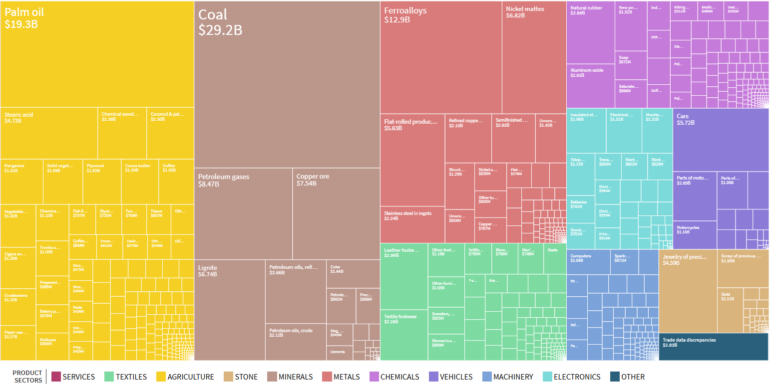

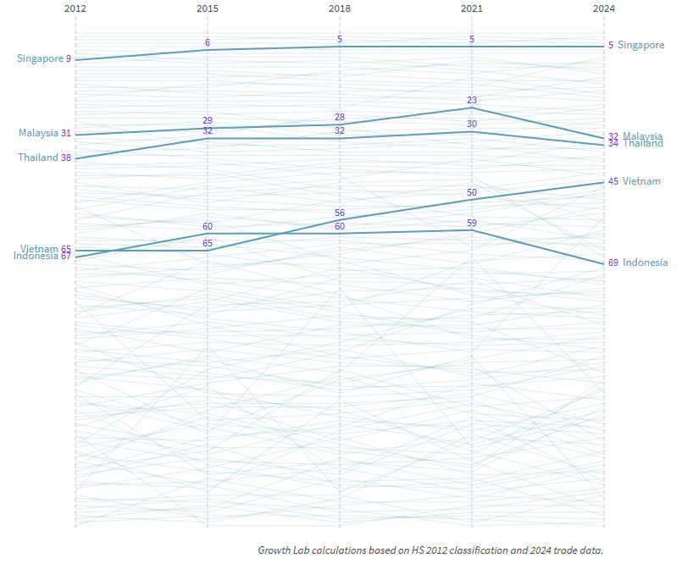

Economic Complexity Index (ECI) Trajectory (2012-2024) from The Atlas of Economic Complexity

